CMPG 325 NETWORKING PROJECT
TECHNICAL REPORT
PROJECT TITLE: NETWORK TOPOLOGY DESIGN AND SIMULATION USING CISCO PACKET TRACER
STUDENT NUMBER: 45408173
STUDENT NAME: MASHAO BOITUMELO BIANCA
MODULE: CMPG 325
LECTURER: FRANCIS LUGAYIZI
INSTITUTION: NWU
SUBMISSION DATE: 16 OCTOBER 2026
- ROLE
Analyzing the assigned scenario, designing, and simulating the network in Cisco Packed Tracer,
- CLIENT
Client ID: CLI-051
Organization: Phokeng Guest House( Rusternburg)
Industry: Hospitality
- CLIENT BACKGROUND
The project's client is a guesthouse that needs a dependable, safe, and orderly computer network to support its day-to-day operations. Administration, Reception, Restaurant Point-of-Sale (POS), Housekeeping, and Guest Wi-Fi services are among the divisions that make up the guesthouse. To carry out their tasks effectively and offer visitors high-quality services, many departments rely on network connectivity.

In order to facilitate guest check-ins, check-outs, and reservation-related tasks, the reception department needs access to hotel administration systems. Network access is necessary for the administration department's office operations and hotel information management. While the housekeeping department needs connectivity to help with internal coordination, the restaurant needs POS terminals to handle payment processing and restaurant transactions. During their visit, visitors also need access to a wireless network.

To support guest house-related data and services, the guest house also needs a central Property Management System (PMS) server. Effective hotel operations depend on dependable communication between authorized staff devices and the server. To prevent unauthorized access to important resources, guest gadgets should be kept apart from the hotel's internal systems.

- NETWORK CONTEXT
  - Topology overview
The network is designed in a hierarchical star pattern. The departmental switches, the hotel router, and the PMS server are all connected by the SW-CORE switch, which serves as the central aggregation point.
Through RTR-PGH, the ISP router simulates an external network connection.

The topology consist of the following devices

- ISP router: Represents the external service provider.
- RTR-PGH router: Provides routing between VLANs and the simulated external network.
- SW-CORE: Connects the router, departmental switches, and PMS server.
- SW-1: Connects Admin and Reception computers.
- SW-2: Connects restaurant POS terminals.
- SW-3: Connects Housekeeping computers and the guest access point.
- PMS server: Provides a central server endpoint for hotel management services.
- End devices: Computers, POS terminals, and guest wireless clients

  - Network structure
The logical traffic flow is as follows

- End devices connect to their assigned departmental switch ports.
- Access ports place devices into the appropriate VLAN.
- Trunk links carry multiple VLANs between the departmental switches, SW-CORE, and RTR-PGH.
- RTR-PGH uses sub-interfaces to route traffic between VLANs.
- The PMS server communicates through VLAN 60.
- The guest access-control list restricts traffic from the guest network to internal networks.
- NAT is configured to translate internal IPv4 addresses for traffic leaving through the ISP-facing interface

4.3 Connections

The following table summarizes the connection used in the design

Source device/interface | Destination device/interface | Purpose
ISP G0/1 | RTR-PGH G0/1 | External network connection
RTR-PGH G0/0 | SW-CORE Fa0/1 | Router-to-switch trunk
SW-CORE Fa0/2 | SW-1 Fa0/1 | Admin and Reception uplink
SW-CORE Fa0/3 | SW-2 Fa0/1 | Restaurant/POS uplink
SW-CORE Fa0/4 | SW-3 Fa0/1 | Housekeeping and Guest Wi-Fi uplink
SW-CORE Fa0/5 | PMS server Fa0 | Server connection
SW-1 Fa0/2–Fa0/5 | Admin PCs 1–4 | Administrative access
SW-1 Fa0/11–Fa0/14 | Reception PCs 1–4 | Reception access
SW-2 Fa0/2–Fa0/9 | POS-1 to POS-8 | Restaurant POS access
SW-3 Fa0/2–Fa0/5 | Housekeeping PCs 1–4 | Housekeeping access
SW-3 Fa0/11 | Guest access point Ethernet | Guest wireless network
Cables used for connectivity
In accordance with the physical topology, the cables link the devices.
RTR-PGH and the ISP router are connected via their GigabitEthernet 0/1 ports.
RTR-PGH G0/0 and SW-CORE Fa0/1 are the connections between RTR-PGH and SW-CORE.
SW-CORE then uses its Fa0/2, Fa0/3, and Fa0/4 interfaces to link to SW-1, SW-2, and SW-3, respectively.
SW-CORE Fa0/5 is connected to the PMS server.
On the designated departmental switches, the end devices connect to access ports.
While access links carry traffic for the VLAN connected to that port, trunk links carry traffic for several VLANs.
The cables used were copper straight thorough and copper cross over.
The guest house’s network may be connected to and managed from a central location thanks to this cabling configuration.
  - IP addressing
The network uses private IPv4 addressing for internal devices and a separate subnet for the simulated ISP connection
VLAN | Network address | Subnet mask | Default gateway
10-Admin | 172.30.26.0 | 255.255.255.192 | 172.30.26.1
20-Reception | 172.30.26.64 | 255.255.255.192 | 172.30.26.65
30-POS | 172.30.26.128 | 255.255.255.192 | 172.30.26.129
40-Housekeeping | 172.30.26.192 | 255.255.255.192 | 172.30.26.193
50-Guest_Wifi | 172.30.27.0 | 255.255.255.192 | 172.30.27.1
60-Servers | 172.30.27.64 | 255.255.255.192 | 172.30.27.65
Each /26 subnet contains 64 total addresses, of which 62 are usable host addresses. This provides sufficient address space for the current devices and future expansion within each VLAN.
The ISP link uses the following addresses
Interface | IPv4 address | Subnet mask
ISP G0/1 | 203.0.113.1 | 255.255.255.252
RTR-PGH G0/1 | 203.0.113.2 | 255.255.255.252

- CURRENT NETWORK PROBLEM
To support its everyday operations across several departments, such as Administration, Reception, Restaurant Point of Sale (POS), Housekeeping, Guest Wi-Fi, and the Property Management System (PMS) server, the guest house needs a dependable and secure computer network. However, managing communication between these departments while maintaining the security of sensitive data is difficult given the current network configuration.

Inadequate network segmentation raises the possibility of unauthorized access to private hotel data and systems since devices from several departments could share network resources. To handle guest check-ins, check-outs, and reservations, the guest house must also make sure that restaurant point-of-sale machines can effectively process transactions. Guests need wireless internet access without having access to the hotel's internal systems, and housekeeping employees need dependable connectivity to coordinate their tasks.

The guest house’s capacity to handle future expansion, especially the addition of additional point-of-sale terminals as restaurant operations grow, is another issue. It may be challenging to add new devices, manage IP addresses, troubleshoot connectivity issues, and maintain dependable communication on a poorly designed network.

- DESIGN CONSTRAINTS
Limited equipment budget—reuse existing switches where possible

- ASSIGNED NETWORKING CHALLENGE
Router-on-a-stick
RTR-PGH is configured to perform inter-VLAN routing through sub-interfaces on GigabitEthernet 0/0. Each sub-interface is associated with a VLAN using IEEE 802.1Q encapsulation.
The main sub-interfaces are:
- G0/0.10 for Admin.
- G0/0.20 for Reception.
- G0/0.30 for POS.
- G0/0.40 for Housekeeping.
- G0/0.50 for Guest Wi-Fi.
- G0/0.60 for Servers.
- G0/0.99 for the native VLAN.
The physical G0/0 interface connects to SW-CORE Fa0/1 using a trunk link.
This configuration allows devices in different VLANs to communicate through the router, subject to the configured access-control rules.

VLANs are used to logically separate the hotel's departments. Each VLAN has its own IP subnet and default gateway.

VLAN ID | VLAN name | Department
10 | ADMIN | Administrative computers
20 | RECEPTION | Reception computers
30 | POS | Restaurant POS terminals
40 | HOUSEKEEPING | Housekeeping computers
50 | GUEST_WIFI | Guest wireless clients
60 | SERVERS | PMS servers
99 | NATIVE | Native VLAN for trunk

The corresponding VLANs are assigned to the departmental access ports. The necessary VLANs are transported between switches and the router via trunk lines.
Traffic organization is improved by dividing departments into VLANs. However, routing policies and access-control lists are also required to implement security constraints; VLAN isolation alone cannot stop all interdepartmental communication.

- Testing
Topology
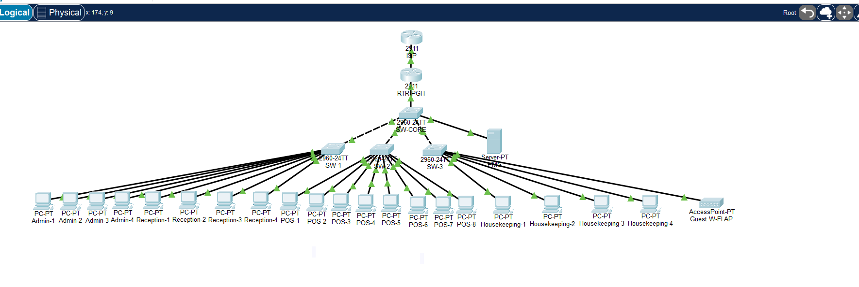
Provided is evidence from the topology
